Community Access Surveys
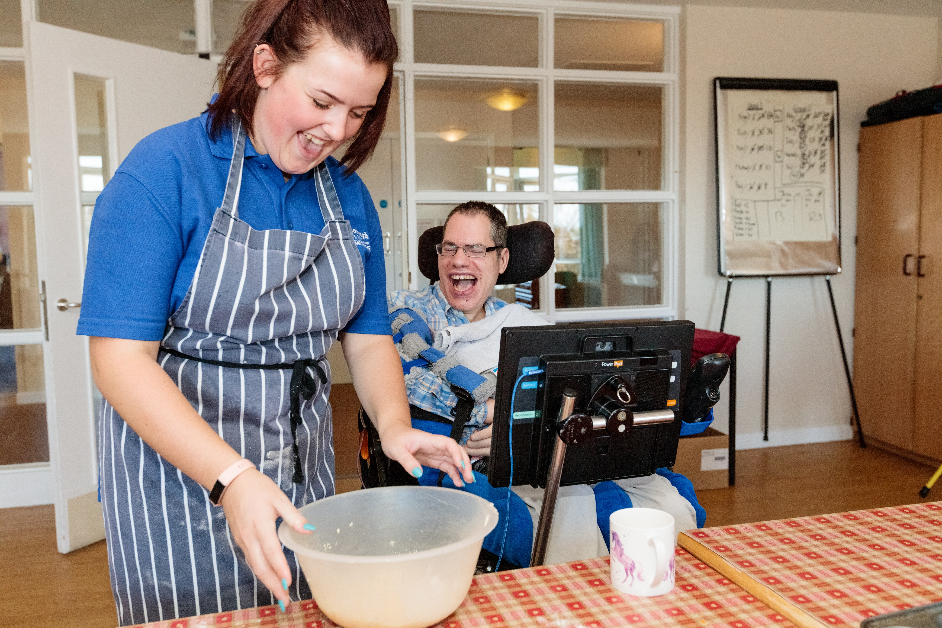

Community Access Surveys

Every day, disabled people have difficulties with things like going shopping, visiting the cinema, using the bank and post office and even playing in their local playground, because facilities and services haven't been designed or provided in an accessible way. Using this tool, you can carry out surveys of your local businesses and other buildings and let people know about the improvements they could make.

How to carry out a community access survey:
1. Decide what you would like to conduct an access survey on:
You can conduct a survey on pretty much anything from your local supermarket, to the busses or even just the high street in general. To really target your survey, it can be helpful to talk to disabled people in your community to find out the areas they have access problems with. You could even conduct the surveys with them.

We’ve provided some survey templates below but feel free to create your own or add in additional points if you feel they should. Below are some examples of things to think about when doing the surveys.
For visits to businesses, leisure centres etc. you should contact them to let them know you would like to conduct an access survey and feedback your findings and recommendations. For transport services etc. you should make contact to find out who to feed back to.

Finally, don’t forget to take your phone so you can take photos of problem areas or things that you think are really good examples of accessibility.

Transport – are there talking buses, a ramp or raised kerb for disabled people including wheelchair users to board and alight trains and buses, do people park their cars on pavements? Are the crossings easy to use? Are there enough safe places to cross the road? Are there blue badge parking spaces?

Streets – is there clear differentiation between the curb and the road? Are there dropped kerbs for wheelchair users to cross safely, is there a lot of litter or bins in the street, do businesses have A boards or seating areas outside? Are there uneven surfaces, overhanging branches or holes in the pavement?

Shops and businesses – are the aisles narrow, are ramps available on steps and stairs for wheelchair users, do lifts serve all floors? Are the payment points easy to reach? Is there help available for people who need it? Are they assistance dog friendly? Do the staff know how to support a disabled person? Are counters and cashpoints in banks at the right level for a wheelchair user? Are there hearing loops available?

Sports and leisure venues - are theatres and cinemas wheelchair friendly? Do they have designated spaces for wheelchair users? Are sporting venues easy to access for disabled people? Does the local swimming pool have equipment to assist disabled people to access the pool e.g. hoists? Do they have audio description? Do the lifts ‘tell you’ what floor you are on?

2. Feedback to businesses and services:
Once you’ve done your survey you need to let somebody know what you have found so write up your findings in a letter to send to the business or service. We’ve provided template letters for both places with good accessibility and places that could make some improvements. You can also send them the tips sheet to help them understand and make the changes. If it is a public service/facility, you can write to the council and you can also write to your MP.
If you would rather send an email, you can download the tips sheet and some email templates.

Access Survey – Building

Date_______________ Location______________________________________________________________

 | Access Survey – Building | Yes | No | Comments/recommendations | Photo number
1 | Is the signage clear and helpful?
2 | Is there an automatic door to get in and out?
3 | Is the entrance wide enough for a large wheelchair to enter the building?
4 | Is there level access or is there a ramp available so that wheelchair users can access the building?
5 | If there are steps inside the building, do they have clear colour contrast on the edges so that people can see the edge?
6 | Is there a hearing loop system? (you may need to ask staff about this)
7 | Is there enough room to move around in a wheelchair or move with an assistance dog?
8 | Is information available in different formats for different people, for example do they have Braille copies of leaflets for people who can’t see?
9 | Is there a lift going to all levels of the building? Is the lift working?
10 | Does the lift have Braille on the buttons and/or an announcement telling you which floor you’re on?
11 | Are staff well trained and sensitive to the needs of disabled people?
12 | Is there an accessible toilet?
13 | Are the counters, tills and tables at a height that wheelchair users can reach?
14 | Is there parking for disabled people (blue badge holders) nearby?

Any other comments

Access Survey – Gym and Leisure Centre

Date_______________ Location______________________________________________________________

 | Access Survey – Gym and Leisure Centre | Yes | No | Comments/recommendations | Photo number
1 | Are the signs around the building clear and helpful?
2 | Is there an automatic door to get in?
3 | Is the entrance wide enough for a large wheelchair to enter the building?
4 | Is there level access or is there a ramp available so that wheelchair users can access the gym?
5 | If there are steps throughout the building, do they have clear colour contrast so that you can see the edges?
6 | Is there a hearing loop system? (you might need to ask staff about this)
7 | Is there room to move around with a wheelchair or move with an assistance dog?
8 | Is information available in alternative formats, such as Braille for people who can’t see?
9 | Is there a lift that goes to all the floors of the building?
10 | If there is a lift, does it have announcements telling you which floor you’re on and Braille on the buttons?
11 | Are the staff well trained and sensitive to the needs of disabled people?
12 | Is there an accessible toilet?
13 | Are the counters, tills and tables at the right height for wheelchair users?
14 | Is there parking for disabled people (blue badge holders) nearby?
15 | Are there accessible changing rooms?
16 | Is there accessible gym equipment?
17 | If there is a swimming pool, does it have a hoist so that a wheelchair user can get in and out of the pool?

Any other comments

Access Survey – Train Station

Date_______________ Location______________________________________________________________

 | Access Survey – Train Station | Yes | No | Comments/recommendations | Photo number
1 | Is the entrance to the train station level? If there are steps is there also a ramp that wheelchair users could use?
2 | Are the ticket office and ticket machines clearly signposted?
3 | Is the counter in the ticket office at a height that a wheelchair user can reach?
4 | If there are stairs to get to the platforms, is there also a lift?
5 | Is there an accessible toilet at the station?
6 | Are staff well-trained and understand how to support the needs of disabled people sensitively?
7 | Is there a ramp available so that wheelchair users can board the train?
8 | Is there enough room on the train to move around easily?
9 | Is there an accessible toilet on the train?

Any other comments

Access Survey – Bus Access

Date_______________ Location______________________________________________________________

 | Access Survey – Bus Access | Yes | No | Comments/recommendations | Photo number
1 | Is there a ramp that wheelchair users could use to get on the bus?
2 | Is there a wheelchair space on the bus?
3 | Are there rails that disabled people can use to hold on to while the bus is moving?
4 | Are there announcements and a visual display so that passengers know which stop the bus is at?
5 | Is there enough room to get around easily inside the bus?
6 | Does the bus driver have a good understanding about how to support disabled passengers?

Any other comments

Access Survey – Playground

Date_______________ Location______________________________________________________________

 | Access Survey – Playground | Yes | No | Comments/recommendations | Photo number
1 | Is there parking for disabled people (blue badge holders) nearby?
2 | Is the route from parking clear and accessible for people with a mobility impairment? (consider gates, steps, etc.)
3 | Is the surface material accessible for wheelchair users and people with mobility impairments?
4 | Are the paths within the playground accessible?
5 | Is there any equipment that is accessible for all or designed for disabled children? (e.g. large swings, level roundabout, sensory equipment)
6 | Are there any access aids? (e.g. ramps, ropes, hand rails?)
7 | Are there accessible toilet facilities nearby?
Any other comments

Access Survey – Streets

Date_______________ Location______________________________________________________________

 | Access Survey – Streets | Yes | No | Comments/recommendations | Photo number
1 | Is there parking for disabled people (blue badge holders) nearby?
2 | Are there dropped kerbs for wheelchair users to cross safely on both sides?
3 | Is there a lot of rubbish or bins in the street?
4 | Are there any cars or bikes parked on the pavements?
5 | Do businesses have A boards, merchandise or seating areas outside which could be difficult to get past?
6 | Are there uneven surfaces, overhanging branches, broken paving, or holes in the pavement?
7 | Is there a clear difference between roads and pavements by crossings (e.g. different textures)?
8 | Are there accessible toilet facilities nearby?
Any other comments

Tips for businesses - what can I do to improve my access?

What sort of changes should I be considering in order to comply with the law and offer a more accessible service?
It's important to remember that the Government estimate disabled people's annual spending power at £249 billion. Offering an accessible service opens up a potentially valuable market. A more accessible service almost always benefits other customers as well - older people and parents with young children often find physical adjustments improve the quality of their service, whilst all customers can benefit from clear signage and information presentation designed for people with visual or hearing impairments.

Adjustments are not always very expensive but can make a big difference. You should try to consider all the aspects of access, and talk to your disabled customers to find out what their needs are, but here are just a few of the steps you could consider:

- Make sure you talk to disabled customers to find out how you can improve access. Think about different types of disability (including, for example, physical or mobility impairments, hearing or visual impairments, learning difficulties or long-term illnesses) and how best you can make your premises accessible to all.
- Ensure that staff are trained in working with disabled customers - many problems can be overcome simply by making certain that staff know what they should and shouldn't do when serving a disabled customer.
- Try to ensure that there is level access to your premises, or if there are steps consider investing in a permanent or portable ramp.
- Find out about your responsibilities under the Equality Act 2010.
- Make sure that your check-out is accessible and that Chip and PIN terminals are moveable to be accessible for disabled customers.
- Try to ensure that changing rooms, if applicable, are accessible and well signposted. Use contrasting colours and symbols to point the way to facilities, as well as looking to fit grab rails or other features to aid access.
- Make sure that staff are trained in Chip and PIN procedures and are also knowledgeable and competent in processing alternative types of card payment, such as chip and signature.
- Think about the layout of the shop floor/venue to make sure that it is possible to move around inside the shop, without being blocked by narrow aisles or obstructions.
- Consider contacting the local council to ask for adaptations like a dropped kerb on the pavement outside the shop if this would help people gain access. Where possible provide disabled parking spaces.
- Make doors easy to open. Doors that require considerable force and only open one way can be difficult for some disabled people to use - easy access to the premises will encourage more disabled customers in.
- Plan accessibility into any future refurbishments. If you are redecorating or rebuilding any part of the premises make sure that access requirements are factored in. It will be cheaper to build them in than to have to add them later.

Template letter for improvements to access needed
[Address 1]
[Address 2]
[Address 3]

[Address 1]
[Address 2]
[Address 3]

[Date]

Dear [name of business manager]

I/We recently visited [name of shop and location] to carry out an access survey to find out how easy it would be for disabled people to visit. After completing the survey, I/we have some suggestions about how you might be able to improve the accessibility of your business.

The following changes would help disabled people access your business:
• (Example 1)
• (Example 2)
• (Example 3)

I’ve attached my full survey with photos for your information.

Every day disabled people face barriers to doing day to day activities such as shopping, visiting the cinema, catching a train, paying their bills, using the bank, or having a drink in the pub. Despite the equality laws much of the UK remains simply inaccessible to many disabled people.

I/We are working with businesses to help put this right.

I hope that the points above are helpful.

Yours sincerely,

[Your name here]

Template letter for good access

[Address 1]
[Address 2]
[Address 3]
[Address 1]
[Address 2]
[Address 3]

[Date]

Dear [Name of business manager]

I/we recently visited [name of business and location] to carry out an access survey and had a really positive experience that I/we wanted to tell you about.

I found that your business has excellent access and caters well for the needs of disabled people. In particular, [insert details of something that stood out about this business].

Every day disabled people face barriers to doing everyday activities such as shopping, visiting the cinema, catching the bus, paying their bills, using the bank or having a drink in the pub. Despite equality laws, much of the UK remains simply inaccessible to many disabled people.

I/We are working with businesses and service providers to help put this right.

I wish to formally thank you for making efforts to ensure that everyone has equal access to your facilities.

Yours sincerely,

[Your name here]

