Shaping future support: the health and disability green paper:
Leonard Cheshire consultation response

Sections:
About Leonard Cheshire
1. Providing the Right Support (p. 3)
2. Improving Employment Support (p. 6)
3. Improving our Current Services (p.16)
4. Re-thinking Future Assessments to Support Better Outcomes (p.19)
5. Exploring Ways to Improve the Design of the Benefits system (p.20)
Appendix – Leonard Cheshire’s recommendations (p.22)

About Leonard Cheshire
Leonard Cheshire is one of the UK’s leading charities supporting disabled people. At Leonard Cheshire we support individuals to live, learn and work as independently as they choose, whatever their ability and to play our part in creating a fair and inclusive society. Led by people with experience of disability, we are at the heart of local life — opening doors to opportunity, choice and support in communities around the globe.

Leonard Cheshire is one of the UK’s largest voluntary sector providers of services for disabled people. We work in local communities to provide people with opportunity, choice and support. We have accommodation services – including supported living and registered care homes; and social, education and leisure programmes – including day support, community outreach and respite support.

We have only responded to questions that are directly relevant or / and have an impact on our work. This response draws on our experiences as a provider of employment and skill programmes to disabled people, and through our research with disabled people.

- Our Skills training and employment programmes
Leonard Cheshire provides skills training to disabled people through employment programmes which aim to address the challenges disabled people face in finding and sustaining employment. These include:

- Can Do
Can Do is a skills development programme for individuals aged 10 - 35 with a disability or long-term health condition to build their confidence through bespoke projects which also give back to their community.
- Discover IT and Go Digital
Across the UK we support people to use technology to gain more control over their lives, including in employment, closely matching equipment and software to the needs and wishes of individuals. Since 2010, we have supported over 13,000 people in this way and in 2018, 1,329 people were supported through our digital inclusion projects.
- Changing Futures
We offer tailored one-to-one support and specialist advice to disabled people seeking and taking up new employment. Our programmes match and prepare people for appropriate and suitable employment and provides in-work support to help participants to settle into their new roles.
- Change Now
Change Now provides young disabled people aged 11 – 25 who are in mainstream and specialist education settings with access to a 1-, 2- or 10-day work experience placement.
- Change 100
Change 100 brings together the UK’s top employers – including Barclays, the BBC, Skanska, Lloyds and Taylor Wimpey - and talented disabled students and graduates to offer three months of paid work experience.

- Our research
Our response is also supported by research conducted with disabled people, including:
- An online survey of disabled people receiving health and disability benefits on the government’s Health & Social Care Green Paper consultation proposals and what further improvements are needed, conducted by Leonard Cheshire. The survey received 694 responses and was conducted from 14th September to 1st October 2021
- Leonard Cheshire’s research findings from a survey of working aged disabled adults. Savanta ComRes interviewed 1,171 working age disabled adults (18 – 65) in the UK between 17 and 30 September 2020. Data were weighted to be nationally representative of working age disabled adults in the UK by age, gender and region.
- Leonard Cheshire’s research findings from a survey of line-managers. Savanta ComRes interviewed 502 UK line managers online with a responsibility for recruitment between 17 and 30 September 2020. Savanta ComRes also interviewed 503 UK line managers with a responsibility for recruitment between 29 June and 19 July 2018. Data were weighted in both instances to be nationally representative of employers by region, company size and sector.
- In-depth, qualitative interviews by Leonard Cheshire with 5 disabled people with lived experience of claiming health and disability benefits in September-October 2021
- Two focus group discussions were held in September 2021 focusing on employment support for disabled young people, which were run by Leonard Cheshire, the National Deaf Children’s Society and Youth Epilepsy.
- One focus group discussion was held with 5 Leonard Cheshire employment support advisers in 2021. Through our employment programmes we offer targeted and tailored support to both disabled people seeking employment and small and medium employers on what they need to do to make their workplaces inclusive of disabled people.

1. Providing the Right Support

Improving reasonable adjustments
The Green Paper highlights ongoing efforts made to expand the range of reasonable adjustments on offer, such as offering a range of communication channels and information formats. This positive work risks being undermined, however, if disabled people aren’t aware that they can request these adjustments or do not feel able to.

Results from our survey found that among those who had never made a request for reasonable adjustments:
- 37% weren’t aware that they could
- 18% didn’t feel comfortable enough to do so

For those that did make requests for reasonable adjustments:
- 34% didn’t have the reasonable adjustments provided
- 33% said that only some of the reasonable adjustments requested were provided some of the time

As table 1. Shows, the reasonable adjustments most requested from the DWP focused on making meetings more accessible (Changing the time and/or date of a meeting- 49% and changing the location of a meeting- 46%), followed by changing the channels through which the DWP communicated with them (Communicating via email instead of by phone- 27%).
Table 1. Reasonable adjustments requested from the DWP

Changing the time and or date of a meeting | 49%
Changing location of meeting | 46%
Communicating via email instead of by phone | 27%
Providing audio recording of interview | 16%
Holding meeting in a private room | 16%
Arranging car parking | 16%
Providing information in an alternative format | 7%
Access to toilet facilities | 4%
British Sign Language (BSL) interpreting | 2%

DWP and the providers of benefits assessments should do more to act as a leading positive example in the provision of reasonable adjustments. If a third of disabled people are not having their requests met, it will damage confidence in making requests from other support services or potential employers during the recruitment process or once in post. This should involve informing disabled people of their right to request reasonable adjustments and potentially providing a list of possible options to request, based on the person’s condition or those most frequently requested in the service region.

To support this work, we recommend DWP monitor the number and type of reasonable adjustments requested as well as subsequent outcomes, which should be used to refine its approach to adjustments and allocating resources to providing them. We also recommend they introduce a ‘tell us once’ service across all benefits they administer and support services delivered, meaning that for disabled people receiving multiple benefits or support offers, all reasonable adjustments are shared and properly provided.

Providing advocacy support
Advocacy support has the potential to improve the advice disabled people receive around which benefits to claim and support in navigating the system and receiving those benefits to which they are entitled. In order to test the principles proposed for advocacy support in the Green Paper, we surveyed disabled people on where they currently receive support from, what this help looks like and what they would like to see in any advocacy support offer.
The majority of respondents (82%) have received some form of help or support for their benefit applications, though among those that did not receive any help, most said they would have liked to have some. As figure 1. shows, help and support most commonly came from friends and family (39%), closely followed by advice centres or local charities (38%). Only 5% of respondents said they received any help or support through services provided by the DWP such as the Visiting Service and Universal Credit or Jobcentre Plus helplines.

Figure 1. Where disabled people receive help with benefits from

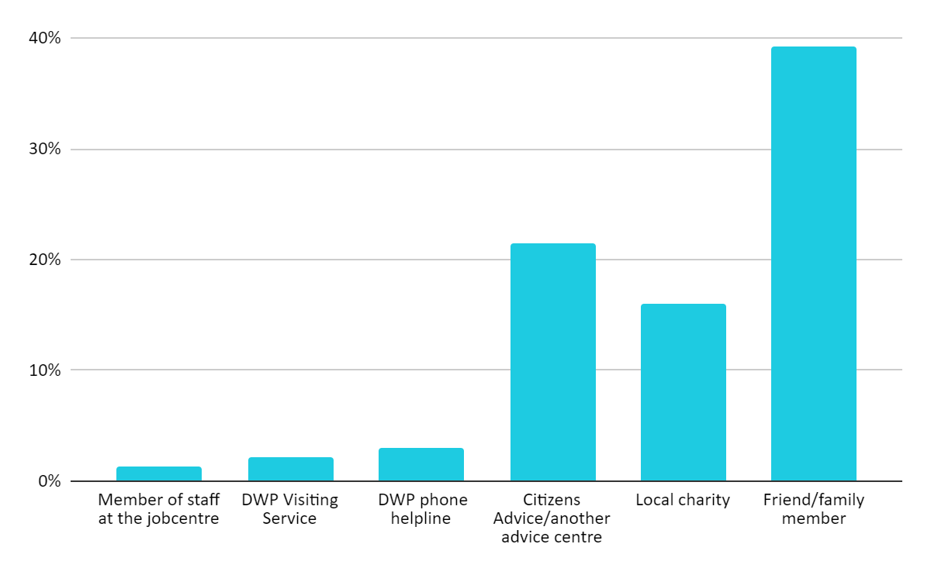
As figure 2. shows, the kind of support disabled people told us they were most interested in receiving was help with filling out forms and paperwork (71%), closely followed by receiving more information and advice on which benefits they should claim (68%). Several respondents also mentioned that it would be important for any independent advocacy support to provide assistance across all parts of their benefits journey rather than just applications and assessments, such as when challenging decisions via mandatory reconsideration.

Figure 2. What help disabled people would like from advocacy support

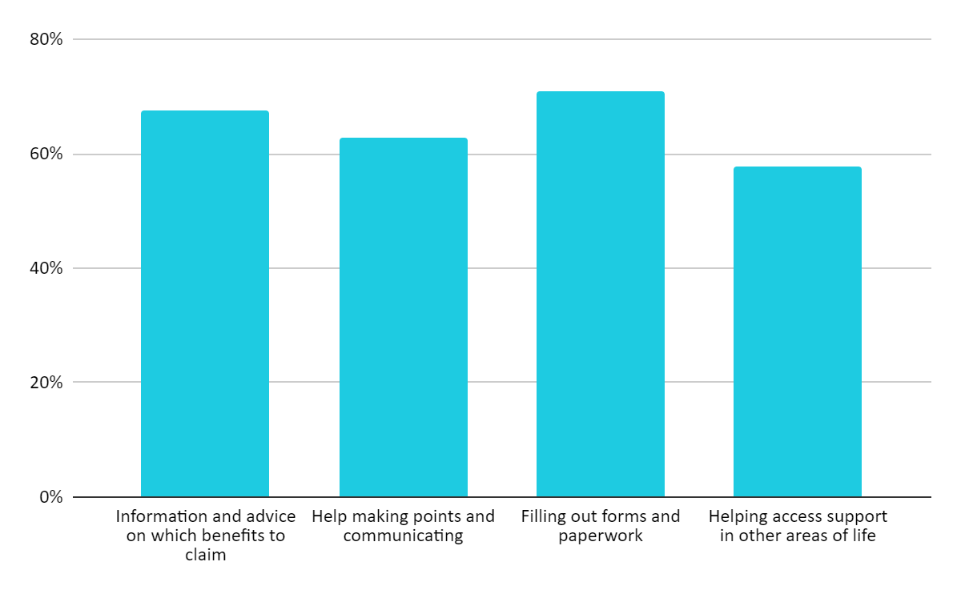
Almost all (92%) respondents to our survey said that an independent advocacy service that provided any of this support would be helpful for them. Responses did not vary significantly across disability or health conditions or based on whether respondents had previously received help or not (but would have liked to) with managing their claims.

“It’s about trust, reliability, and access. I need an independent advocacy service that is on my side”
Survey respondent

Those who benefit from this support might be those new to the system or equally those who have received disability benefits for a long time, even without a deterioration in their disability or health condition. Some respondents indicated they felt worn down by assessment processes and thought they were now less able to advocate for themselves than previously.

“Attending medical appointments with me and other DWP appointments [would help] because I can't speak because it's too stressful now. I wasn't like this before six years ago. [The] system has made me worse and I'm very isolated”
Survey respondent

We broadly agree with the principles proposed for advocacy support but believe that some may be difficult to implement in practice when designing independent advocacy support. One principle is that ‘advocacy should not duplicate existing support but fill gaps in provision.’ However, 18% of disabled people told us that they received support from a local charity, many of whom operate on limited budgets year-on-year and may introduce changes to eligibility criteria for support. Maintaining an on-the-ground picture of existing support, in order to direct funding to plug these gaps, may be challenging in this regard and will require regular stakeholder engagement with local authorities, third sector organisations and advice bodies.

Another principle states this support should ‘only be offered to the people who
need it most,’ which may include ‘people who do not already have the support of charities and other organisations.’ Only 33% of disabled people told us they have received help from advice agencies or charities, meaning that in the wider context of a regional variation in availability of advice and advocacy support, most disabled people are currently not receiving support of the kind proposed in the Green Paper.

As part of developing this advocacy support, we recommend the DWP should remove the current requirement of repeated “explicit consent” in order to communicate with claimants’ advisers on Universal Credit matters. Being able to rely on “implicit consent” would be important if problems with claims are to be promptly and effectively resolved.

Signposting and support to help people
Improving efforts to signpost and refer disabled people to other services (such as housing, health, and debt advice) could have a positive impact for many people in enabling access to wider support. Referrals and signposting are most successful when coming from a trusted source. Research from Demos found that only 20% of the public felt that the DWP understand the concerns and issues facing disabled people, this was similar to the level for local councils (21%) but far behind the NHS (59%) and third sector organisations (62%). We acknowledge much work is being done to improve trust in the DWP its staff and the wider benefits system and suggest this work continues in order to improve likelihood of referral take-up.

We recommend that, wherever feasible, once a potential support need is identified for disabled people by DWP staff, that a warm referral is made to the relevant service. A warm referral takes place when there is a direct interaction between the organisation who is referring someone on and the service provider, with that person’s details directly passed on. This approach minimises the risk that people will fall through the gap in the signposting process, improving the likelihood of the uptake of the new support offer.

2. Improving Employment Support

Access to Work and Disability Confident
Access to Work can be a lifeline for disabled people and people with health conditions. Despite the support it provides being highly valued by many disabled people who have availed of it, the programme still faces longstanding issues around awareness, applications and delayed payment processes. These need to be addressed to make it fit for purpose for disabled people and employers.

The forthcoming trial of Access to Work Passports has the potential to aid disabled people at transition points, ensuring support and equipment stays with them as they change jobs and act as an important tool in communication between line managers and new disabled staff members. However, this will only help those already receiving payments for support and equipment via the programme, which at present is still underused.

In recent years, there has been no significant extension of the programme: 37,170 people received a payment from Access to Work in 2020/21, while in 2010/11 payments were made to 32,810 people. This marginal increase over a decade can be seen in government spending related to Access to Work (In 2020/21, £106.6 million was spent on the programme compared to £127.6 million in 2010/11).

Research from Leonard Cheshire highlights further issues around uptake and processing of applications:
- Only 23% of disabled adults in the UK (currently or previously working) say they have ever received Access to Work support
- In Scotland and Wales, this figure is as low as 14%, while in Northern Ireland it drops to as low as 10%
- 69% of disabled people who currently or have previously received Access to Work support have had to wait more than 3 months for their application to be approved

“Access to Work [should be better] available, I waited nearly a year to talk to the person, I have NO confidence I'd get this service up and running [from day one in a new job]”
Survey respondent

We recommend that a proactive marketing campaign needs to be undertaken, particularly in the devolved nations to ensure that disabled people and employers are aware of the support available through Access to Work to fund the reasonable adjustments which many disabled people need. Improved data collection on patterns of use of the scheme, such as across employee demographics, and location and sector of employers could help with any targeted promotion efforts.

In the longer-term, Access to Work should be reformed via efforts to reduce bureaucracy and long waits following applications. This can be done by providing a comprehensive assessment carried out by trained assessors as well as end-to-end support to use and maintain any equipment provided by the scheme.

The feedback Leonard Cheshire has received from the disabled people we work with is that the advice they receive from Access to Work advisers is often out of date and does not always promote apps and easily accessible technology on mainstream devices. This can mean delays to accessing readily available support or that disabled people are advised to purchase Assistive Technology that is not compatible with their employer’s IT system. Advisers should be able to draw on up-to-date information on the growing importance of Assistive Technology in removing barriers to work and helping disabled people stay in work.

Disability Confident
In its current form Disability Confident is not making a meaningful contribution to enabling employers to improve recruitment and employment practices or supporting disabled people to find and remain in work. Latest figures show that there are over 20,000 Disability Confident employers, but less than 1% are Disability Confident Leaders (level 3), a status which can be reached without an organisation having to employ a single disabled person.

This is particularly concerning given that Leonard Cheshire research recently found:
- Only 21% of employers said their organisation has recruited a disabled person in their workforce in the past 18 months
- In 2020, 33% of employers said they employed a disabled person in their staff, a decrease from 49% in 2018

Action is needed to ensure that all employers are meeting their legal responsibilities under the Equality Act and treating everyone equally irrespective of disability. There is also much more that can be done to positively encourage better recruitment and employment practices from employers. Schemes like Access to Work and Disability Confident can play an important part in this.

Meaningful reform of the Disability Confident scheme is needed to ensure participating employers offer inclusive workplaces and genuine support to disabled people. This should include a process of external validation and assessment to measure how employers are performing in attracting disabled people in recruitment and retention in terms of job outcomes as a result of the accreditation.

An important measure of disability inclusive workplaces would be via the introduction of employment and pay gap reporting. All employers with 250+ employees should publish data annually on: the number of disabled people they employ as a proportion of their workforce; their disability pay gap; and the percentage of disabled employees within each pay quartile.

Providing more support before the Work Capability Assessment
The Green Paper notes that as a result of the pandemic, there may be increased demand for Work Capability Assessments due to a greater number claiming UC with LCWRA and New Style ESA. The Green Paper also notes that a lasting shift towards home working may have been brought in, which could positively impact opportunities for disabled people and people with health conditions. These changes are linked to the proposal to provide employment support prior to a Work Capability Assessment for those who have recently left work.

During the most recent quarter for which data is available (April-June 2021), 12% of both disabled and non-disabled people reported working ‘mostly from home.’ This is double pre-pandemic levels, but still represents a very small minority of employees and shows disabled people are no more likely to be able to avail of home-working practices than non-disabled people. Many disabled people will have benefitted from home-working, but many more face barriers to these working practices, as 18% of disabled people have never used the internet, while others may not have Assistive Technology that makes online home-working a possibility.

It is this current context, along with findings from our research, that suggest efforts to provide more support before the Work Capability Assessment could be best targeted elsewhere. While flexible working has been shown to benefit some disabled people and should be encouraged, this encompasses wider practices than simply working remotely. The current consultation on the right to request flexible working arrangements from the first day of work at a new employer is a considerable step forward for equal opportunities in the workplace for disabled people. Although for disabled people, even with these working practices in place, their condition may necessitate leaving the labour market, meaning that support prior to Work Capability Assessments may not be best targeted at this group.

Our survey asked disabled people if receiving employment support before their Work Capability Assessment would have been helpful, the majority said it would not have been:
- 46% said it would not have helped in their situation
- 15% said it would have been unlikely to help in their situation

“I was struggling with my mental health. It took me changing to a new GP and getting specialist help. I think I really needed to get the right help first before thinking about returning to work.”
Survey respondent

“I had always put my mental health on the back burner & been on auto-pilot, my mental health has to come first, so it is unlikely I would have looked at alternative employment as my underlying significant mental issues would have remained unresolved.”
Survey respondent

A common theme that emerged in the reasons why respondents wouldn’t have found this helpful, was that managing their health condition or disability (particularly mental health problems) was of greater importance and needed to be carried out before they could consider looking for any alternate employment.

An offer of employment support prior to the Work Capability Assessment is aimed at preventing this group from losing touch with the labour market and reducing the chance of being out of work in the long-term. However, according to the NAO, the average length of time between declaring a disability or health condition and receiving a decision from assessment is four months. Discussions of work-related activity when appropriate could be started sooner, reducing risk of long-term unemployment if assessment happened sooner.

Supporting young disabled people into employment
Leonard Cheshire’s research has found that young disabled people are experiencing a crisis of confidence regarding their future employment prospects, including wages that are up to 20% lower twenty years later than they would otherwise have been. This has only been exacerbated by Covid-19, with many now facing multiple disadvantage, who risk becoming a “lost generation” due to the impact of the pandemic on the labour market and their participation in work, training and economic.

Research conducted in the first three months of the pandemic found that among young people (aged 18-24):
- 44% felt that Covid had a negative impact on their future career ambitions (compared to 42% of all working age disabled people)
- 54% felt that Covid had a negative effect on their future earning potential (compared to 48% all working age disabled people)
- 71% told us Covid had a negative effect on their ability to work (compared to 45% all working age disabled people)
- 84% reported their work being impacted by the pandemic (compared to 71% of working age disabled people)

Since then, figures show that young people face a 5-year high in unemployment levels, with 260,000 fewer young people in work compared to March 2020, representing 46% of the total fall in employment since Covid. Young disabled people were most likely to have been affected by these job losses, as the employment rate for this group fell by 1.8 percentage points. This leaves many of this group at risk of the potential scarring effect of long-term unemployment on mental health, wellbeing, and future earnings potential unless targeted action is taken to prevent this negative impact. Our recommendations specifically aimed at addressing the immediate impact of the pandemic on disabled young people as well as better managing transitions into the workplace are detailed below.

Kickstart & targeted programmes
The Green Paper mentions the Kickstart Scheme, to those between 16 and 24 years of age on Universal Credit, as an example of the targeted support introduced since Covid to help disabled young people and people with health conditions move into work. Though the scheme’s introduction has been a positive for young people, Leonard Cheshire have called for several improvements to be made to ensure it is better tailored to disabled young people. These focus on access, delivery, and evaluation, and should be considered for any further extensions to Kickstart or new schemes.

There are currently 170,000 young people claiming Employment and Support Allowance or with a with Education, Health and Care plan who are currently locked out of participating in this scheme. We recommend that any training and employment programmes for young people should ensure they are extended to include these groups.

“I am in Kickstart but I didn’t know about Access To Work even before interviews”
Focus group participant

We recommended Kickstart to be better linked in with existing support for disabled young people. Access to Work support should be in place on day one of a disabled young person’s Kickstart placement for the scheme to be successful.

One participant in our employment support focus group was currently on a placement as part of the Kickstart scheme, with mixed experiences of the process. Though they had found the recruitment process positive and grown in confidence, they faced issues in organising specific disability awareness for their team. In this situation they would have benefited from advisers linked to the scheme being able to liaise with employers throughout and ensure that things like this were accommodated and wider positive working practices introduced.

Though it may not have been practicable beforehand, given the speed of action needed due to the pandemic, we note that equality analysis for Kickstart, and resultant proposed mitigation to address barriers to engagement for disabled young people, was only published 10 months after its introduction. We recommend that all new employment and training programmes should have an Equality Impact Assessment published prior to launch, outlining how they will be inclusive and accessible to disabled young people.

We have been calling for the Kickstart scheme and participating employers to be evaluated. Effective evaluation would help to ensure that meaningful skills, training and, most importantly, job outcomes for young disabled people were delivered over the course of the scheme. Despite this no mechanisms to record the number of disabled young people participating were included within the initial design of Kickstart. We recommend such data collection mechanisms be built into all future employment and training programmes to allow for effective monitoring of uptake by disabled young people throughout

Managing transitions
“I didn’t know about apprenticeships, types of courses, or internships, or any of the paths I could go down which weren’t university or work.”
Focus group attendee

A key theme across our focus groups was that careers guidance at school was generally unhelpful as it often focused primarily on preparing for university, with little else available for disabled young people for whom this was not a desired choice. One example of this was a participant’s school’s ‘careers fair’ being comprised solely of universities. This is particularly of concern given that recent figures show that one of the largest falls in employment (5 percentage points) from 2019-2020 was for disabled people with NQF Level 2 qualifications.

Where one-on-one career guidance was available, this was similarly mixed. Participants spoke of career advisors holding low expectations on the opportunities available to them because of their disability or not providing any information on what adjustments they might need in the workplace and what kind of support or opportunities are available. The majority of participants were not familiar with Access to Work and those that were, had found out about it by themselves rather than being given this information through career guidance or advice.

“They should be explaining about [Disabled Student Allowance] and Access to Work, they should be saying there are funds available about extra support and these schemes. Careers advisors need to know this.”
Focus group participant

We recommend the Government make it mandatory for schools and colleges to provide disabled young people with tailored careers guidance including the provision of information about Access to Work, Disability Confident and employment support schemes. The forthcoming trial of Access to Work Passport coupled with the DfE’s SEND review provides a key opportunity to help improve disabled young people’s transitions from education to the workplace. We recommend Access to Work Passports are included in the updated Codes of Practice for schools and colleges.

We also recommend that where possible, Disability Employment Advisers are drawn on to support the work of the Jobcentre Plus Support for Schools programme, which targets young people aged 12-18 who are at particular risk of being out of education, employment or training. Evaluations of the scheme have found it to be well received in general by both students and school staff, but the DWP must ensure all outreach and information provided can be tailored to disabled young people needs and aspirations.

Greater joint working should occur between DWP and DfE to help young disabled people at these transition points. We recommend the introduction of a ‘no wrong door’ approach, with collaboration from both departments to create a joined-up offer for young people. This will enable Work Coaches at JobCentre Plus to advise on skills programmes like Supported Internships and Apprenticeships, and colleges to promote employment programmes. A possible site to pilot this joined up approach could be through the 110 newly launched Youth Hubs helping young jobseekers access local training and job opportunities, as well as a range of services to address wellbeing needs.

Conditionality and tailored employment support
“[The system] needs to be focussed on the applicants’ NEEDS and not on rules, conditions and then sanctions. Many people with mental health problems, including me, feel threatened by the current rules-based system and I was personally frightened and scared I would get sanctioned.”
Survey respondent

“[As an example], if a business doesn’t care about its employees, I mean why would you even employ them, because they’re not going to do their job and they’re not going to be happy. If you ask someone with a brutal question, chances are that person’s not going to like you or do what you ask. If you’re kind and respectful people will like and appreciate that. But I do feel that the DWP are tough from a starting position. You need to change the whole ethics system around it, so they're treating people with genuine human kindness, basically investing in their future. Power is at the heart of it, but the question is, are the DWP using their authority to good ends?”
Interviewee who has claimed Universal Credit

For many disabled people the setting of any work conditionality or job-search requirements by their Work Coach has been a largely negative and stressful experience. Many disabled people who were quite unwell were found to have been given generic commitments with 35-hour weekly job-search requirements, while research from Citizen’s Advice in 2018 found only a third of advisors surveyed said their clients “understand what they need to do to fulfil their claimant commitment.” Even more worrying were findings from DWP research that only one in five disabled people felt the activities in their claimant commitment took their circumstances into account, while one in 10 people with a long-term health condition reported that they did not remember agreeing a claimant commitment at all.

As such the new approach to conditionality, whereby disabled people start from a possible base of no mandatory requirements, with voluntary steps and, used with discretion, mandatory requirements if and when they are needed, is a positive step forward. More could be done to build on this and reduce the stress disabled people often feel about this process and the anxiety of a potential sanction for non-compliance.

We previously called for work conditionality and benefits sanctions to be suspended for the duration of the pandemic. As restrictions have lifted and health and safety risks, though still present for many disabled people, can be better managed, sanctions and work conditionality have returned to the benefits system. Despite the new formalised approach to conditionality and the new informal approach Work Coaches appear to be taking to sanctioning decisions, the threat of sanctions is still a source of anxiety for many disabled people.

The suspension of sanctions for disabled people could remove the ‘fear’ factor inherent in the system for many. Recent figures show that sanctions for ESA Work Related Activity Group are at their lowest level since the current sanctions regime began (0.01%), meanwhile the proportion of Universal Credit claimants subject to conditionality who have received a sanction fell to 0.11% in May 2021 from 1.9% in March 2020.

In 2016 the DWP estimated it spends over £240 million a year administering conditions and sanctions. It is likely that this estimate has fallen since then, but it must be recognised, beyond considerations of costs, that removing sanctions for disability benefits would bring about a fundamental shift in the way in which the system currently operates and is perceived by disabled people. Previous research has also found sanctions to have no tangible positive effects in moving disabled people closer to paid work. With sanctions removed, Claimant Commitments could become an effective and fair tool that truly supports disabled people. To further support this DWP staff setting Claimant Commitments should have sufficient training and awareness on disability and its impact on employment and be able to draw on the support of Disability Employment Advisors in doing so.

Guidance should be developed on the appropriate as well as inappropriate use of the Claimant Commitment, specifying the situations in which different levels of conditionality would be applicable, with multiple real examples. Given increasing efforts by the DWP to promote better working with health services, Work Coaches should be informed that including health related activities in Claimant Commitments are not appropriate. Mind have found examples of Work Coaches requiring people with mental health problems to attend therapy and support groups, or risk facing a sanction. Though likely well intentioned, this can be hugely damaging as it risks undermining a person’s relationship with health services and willingness to seek help in the future.

The DWP should also continue to increase and protect the number of Disability Employment Advisers going forward, who receive regular up-to-date training so as to most effectively support the work of Work Coaches. Though the number of Full-Time-Equivalent Disability Employment Advisors has reached a high of 687 in Q1 2021/22, this was only after reaching a low of 242 in Q1 2020/21. In future staffing rates should be monitored to ensure that numbers of Full Time Equivalent DEAs does not drop below a set threshold, which should certainly be well above that 242 figure. 315 new Disability Employment Advisors were promised in April 2021, bringing the total number to 1,115 once recruitment is complete, aiming to build on the previous recruitment of 13,500 Work Coaches. The number of Disability Employment Advisors relative to Work Coaches, and disabled people claiming out of work benefits should be monitored, to ensure there is always sufficient expertise available to support disabled people.

Digital employment support
Utilising digital tools and providing online employment support for disabled people has the potential to both improve uptake through remote engagement and deliver innovative and tailored support to people, if done effectively. However, at present, our research suggests that disabled people are more likely to be opposed to or uncertain about the idea of receiving employment support digitally.

Our survey found that:
- 26% would not like to receive employment support digitally
- 33% didn’t know if they would like to receive employment support digitally
- 14% would like to speak to an employment adviser via a video-call
- 23% would like digital employment support to include access to learning or training resources and support

We recommend that any digital employment offer include availability of a combination of accessible formats such as video calls or online messaging, as well as trying to utilise online tools to tailor support that disabled people can avail of in their own time.

Encouraging people in the Support Group or with LCWRA to take up
support
“[I would like them to] provide tangible support in all/any formats possible. I have never received any - not even a letter. I only receive monetary support, which is very beneficial, but does not make me feel supported holistically.”
Survey respondent in the Support Group

Among the 20% of people in the Support Group and with LCWRA who would like to work and think they would be able to in the future, many will have minimal contact with the DWP. A starting point to any outreach encouraging anyone in these groups to take up support, should be first identifying who should not be contacted. Disabled people with severe and progressive conditions should not be contacted regarding such opportunities. Then any communication with the remainder of this group should make clear that engaging with this support offer is entirely voluntary.

Any employment support should be provided by staff with expertise in the disabled person’s condition to help address the barriers they face in moving into employment. From our survey the main barriers to employment of disabled people in the Support Group or with LCWRA, who would like to work in the future felt they faced, were structural. As figure 3. shows, eight in ten (80%) saw employer attitudes to disabled people as a barrier for them, while lack of accessible local transport was an issue for one in three (29%). The main personal barrier respondents identified was a lack of self-confidence in being able to carry out paid employment (56%).

Figure 3. Barriers to employment for disabled people in Support Group or with LCWRA who would like to work
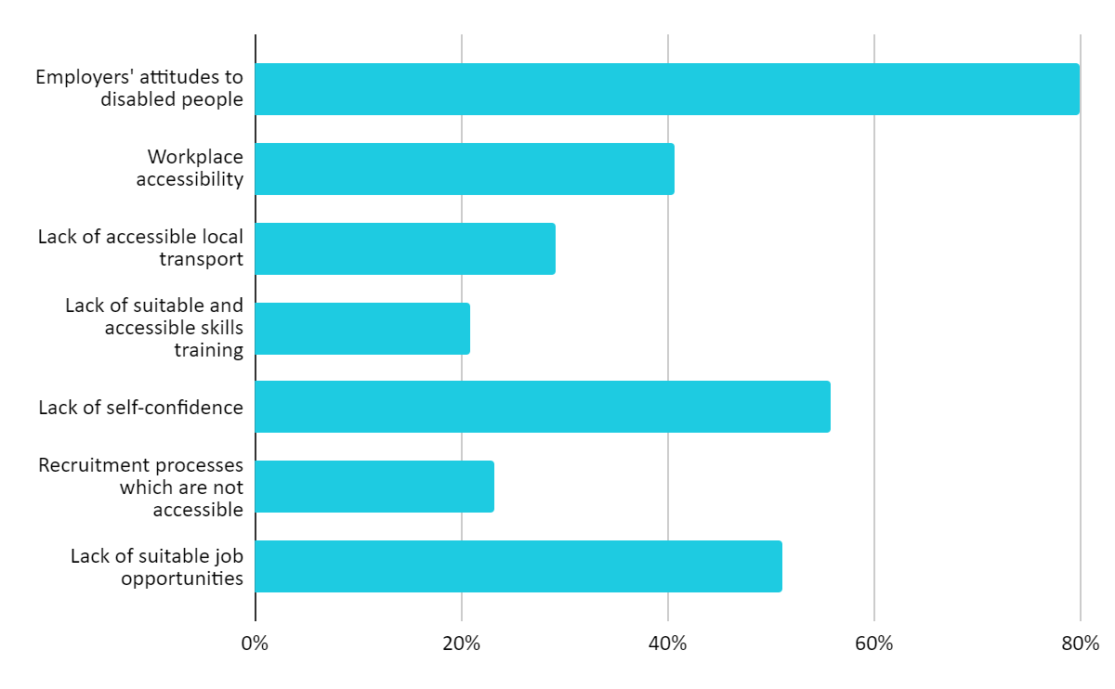

Employer attitudes is a significant issue, as further Leonard Cheshire research has found. In 2020, 20% of employers in the UK told us that they were less likely
to employ a disabled person. Any employment support offer to disabled people in the Support Group or with LCWRA must be tailored and carefully developed with these entrenched attitudes and barriers in mind.

3. Improving our Current Services

Exploring different ways to conduct assessments
As a result of the pandemic, in many cases it has not been possible to conduct face-to-face assessments, meaning the DWP has been carrying out assessments by telephone. The Green Paper notes that initial research has found disabled people are largely satisfied with having their assessment for PIP or their WCA through this channel.

For telephone assessments to remain an option going forward they should deliver consistent decisions with other channels and be a format that disabled people are comfortable with. To assess the latter as well as other any channels through which disabled people have had assessments, we asked those we surveyed about how they found these experiences (independent from their satisfaction with the outcome).

Preferred ways of conducting assessments
As Figure 4. shows, irrespective of the channel, respondents to the survey do not find going through assessments an overall positive experience. Only 12% said they felt positive about face-to-face assessments, while phone was the channel that respondents were most positive about, this was only the case for slightly over a quarter (27%). Assessments carried out on papers was the only channel for which more than half did not have a negative experience of (59%).

Figure 4. Experiences of assessments through different channels

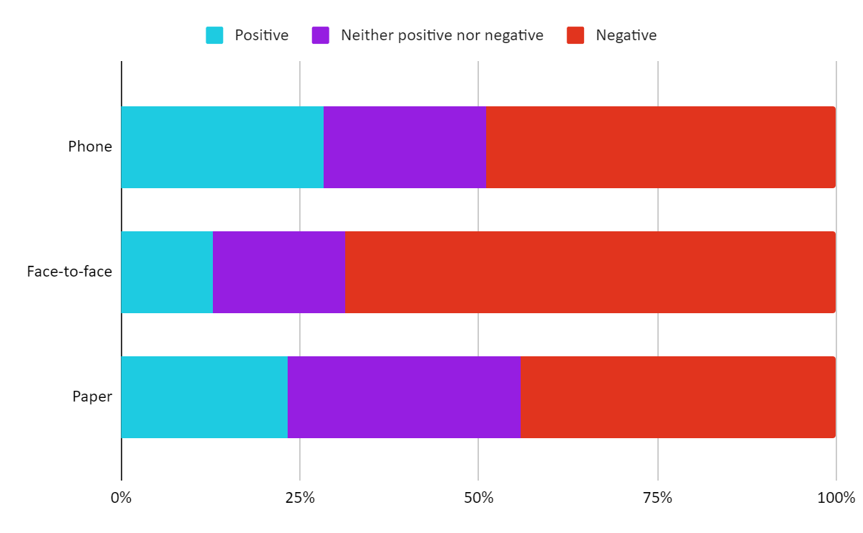

Importantly, despite the overall experience across all assessment channels tending towards negative, when asked what their preferred assessment channel would be if given the choice, opinion was almost evenly split. As figure 5. shows, phone was the most popular option (39%), closely followed by paper (37%). Despite the apparent overall negative experiences of the format, a third (32%) chose face-to-face, with a quarter (25%) saying they would like video calls if given a choice.

Figure 5. Preferred choices of channels for assessments

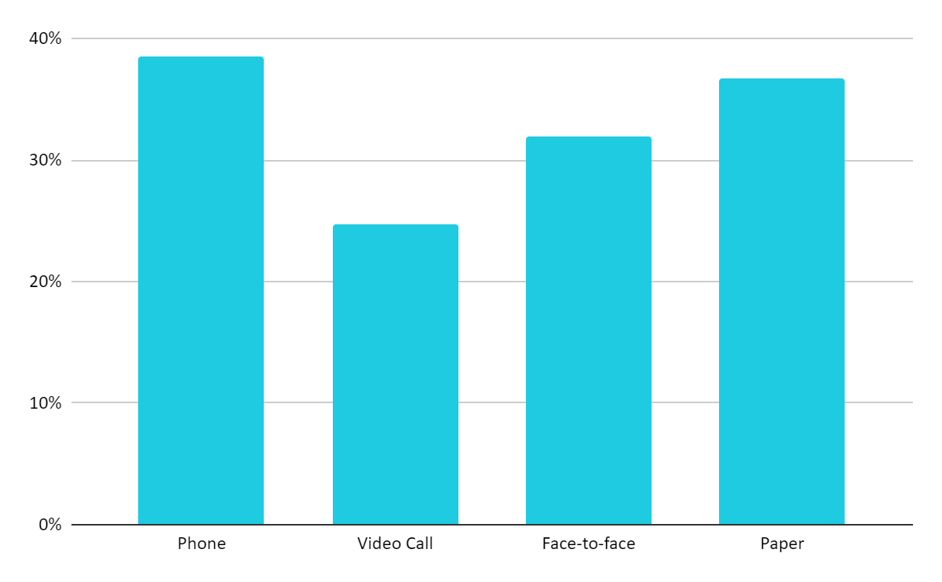
Wherever feasible, we recommend that disabled people be allowed to choose from assessment channels (phone, video, face-to-face, paper) rather than being presented with a default option.

Improving accuracy
Issues with the accuracy of reports produced following assessment has been a long-standing concern for disabled people. Of those surveyed who had seen a copy of the report for any of their previous assessments, 85% were dissatisfied with its accuracy. Attempting to correct any inaccuracies in reports was a strong theme to emerge from the in-depth interviews we conductions. When asked if there was one immediate improvement that could be made across the health and disability benefits system, two of the five in-depth interviewees said that they would like to see recordings of non-paper assessments be provided to disabled people as standard.

“What I found was helpful was insisting that [my assessment] be recorded. Because I think it reins them in and puts them on their best behaviour. So, I would never do it without that. I know what I’m going to say, so I didn’t need to record it from that point of view, it’s more to say ‘don’t cross the line.’”
Interviewee in ESA Support Group

Prior to the pandemic disabled people who wished to record their face-to-face assessment were allowed to do so only using audio equipment that met specified DWP requirements, which could cost up to £120 to obtain. The DWP has recently confirmed that private assessment contractors, Atos and Capita, have introduced audio recording of phone PIP assessments for some disabled people since late 2020. In addition, the DWP suggested that they were working with both assessment providers to find a suitable method for audio recording with the reintroduction of face-to-face assessments.This is a positive step but at present, is unclear how widespread this will be. We recommend that the DWP require contractors to record all face-to-face, phone and video assessments as standard, holding them for a reasonable set period of time to be requested by disabled people, rather than requiring them to opt-in to recording.

To further improve accuracy, we recommend the DWP automatically issue claimants with a copy of their assessment report, in their required format. This would increase scrutiny, helping hopefully in turn to raise standards, and work to rebuild some of the trust disabled people have lost in assessors’ ability to act fairly and independently. In situations where an assessment diverges from the account a disabled person gives of their condition by the claimant, this difference must be clearly explained by the assessor in question. Suitable avenues must be provided to address this.

4. Re-thinking Future Assessments to Support Better Outcomes

Assessment reform
Since its introduction a range of structural issues with have been repeatedly highlighted in the Work Capability Assessment (WCA) including its inability to account for the barriers that disabled people and those with long-term health conditions face when accessing employment, and inability to adequately capture the day-to-day impact of certain conditions on disabled people.

Some of the changes that are needed can be short-term in nature, improving the process and outcomes for disabled people in the present here and now; whilst addressing some structural issues may require a longer-term approach. For both, it is imperative that disabled people are meaningfully engaged in consultation on what improvements look like.

Some key principles for immediate and the longer-term structural changes to the Work Capability Assessment were tested in our survey to assess their support from disabled people with experience of the Work Capability Assessment. Among immediate changes, by far the most popular principle was that assessments take into account fluctuating conditions, rather than trying to capture a ‘snapshot’ or ‘typical day’ (88%). Three quarters of respondents (76%) wanted evidence other than medical evidence to be equally considered during an assessment.

When considering longer term structural changes a majority (62%) of respondents agreed that there should be a focus on supporting people instead of any work-related conditionality or sanctions. However, there was not substantial support for the two other principles for longer term change: Access to a support coordinator after the assessment, to help draw up a support plan, on a voluntary basis (20%) and providing a holistic assessment of barriers to work that focuses more on external barriers (16%). This may reflect a hesitancy of respondents to make a judgement on the proposals without further detail, rather than a lack of support. Any new longer-term measures should be designed in consultation with disabled people and piloted to assess effectiveness.

Table 2. Support of principles for change to the Work Capability Assessment
Principles for immediate change
Taking into account fluctuating conditions | 88%
Ensuring evidence other than medical evidence is equally considered | 76%
Principles for longer-term change
Receiving access to a support coordinator after the assessment to help draw up a support plan | 20%
Providing a holistic assessment of barriers to work that focuses more on external barriers | 16%
Focusing on supporting people instead of any work-related conditions or sanctions | 62%

Evidence gathering
Many respondents to our survey and interviewees told us that they encountered medical evidence they provided for their assessments being ignored. This might have been the case for many reasons but could potentially be due to greater weight being given to the assessor’s report over this evidence, or the quality and detail of the evidence, though coming from a qualified medical professional, not being sufficient. This lack of clarity causes considerable frustration and distress and leaves disabled people feeling the system distrusts them and their healthcare professional who both know their condition and its impact best.

We recommend that the DWP commission an independent review of the
evidence-gathering processes in order to explore ways to:
- support health and social care professionals to provide better-quality evidence, for example guidance and templates
- ensure the duties and responsibilities of the assessor, the DWP and claimant are clear and observed
- make sure the DWP has a strategy to communicate to claimants and health professionals the evidence that will be most useful for the claim
- ensure evidence supplied by relevant professionals (medical or otherwise), friends and family members is given due consideration.

We recommend that better guidance be provided on what constitutes good evidence. Disabled people often need to source and present evidence to substantiate their claim but are given little support in doing so. The DWP should work with medical practitioners to develop better-quality evidence for disabled people. Often, medical evidence that is obtained provides nothing more than a diagnosis, rather than any detail on how this condition impacts a person’s day-to-day activities or wider needs. Assessors should also be obliged to review all supporting evidence provided by a claimant, with penalties if they do not. All this evidence should be given equal weight to the reports produced by assessors.

5. Exploring Ways to Improve the Design of the Benefits system

One proposal in the Green Paper on better supporting disabled people to live independent lives was through improving awareness and/or access to aids, appliances and services. It was suggested that the DWP explore the potential to allow people to voluntarily swap all or part of their benefit payment for such aids, appliances, or services, with this offer operating in a similar way to the Motability Scheme.

The responses from our survey to this proposal of such a scheme being made available to them were considerably mixed. 43% said they would be interested in trading part or all of their award, while a quarter (25%) said this wouldn’t be of interest to them, and a third (32%) said they weren’t sure or would need more information about how this would work in practice.

“[I would be worried that] things such as hearing aids which you are entitled to on the NHS would have to be paid for out of PIP which isn't right. A lot of people need PIP for heating etc as the other money isn't enough, aids should be free”
Survey respondent

Some of the key concerns raised underlying this uncertainty or opposition to the proposal were around affordability and choice- that inadequate options could be available and would be expensive relative to the wider market. Many respondents also highlighted the current inadequacy of benefit levels meaning that if they were to trade some of their award, they would be unable to afford food or heating. In principle some respondents opposed this proposal as they believed aids, appliances, and services they need should be provided free of charge rather than being required to trade some of their PIP award to pay for them. While others were concerned what availing of this equipment and support might mean if and when they received a reduced PIP award in the future.

Given these concerns it is important to emphasise that health and disability benefits are entitlements, whereas services may be cut or rationed to a degree that makes access to them problematic. Ensuring adequate provision and access to support and equipment is an issue to wider services as well as the benefits system, but simple trade-offs such as those proposed do not address this most effectively.

Contact
For more information and further detail including data sets, please contact Nic Murray, Policy Manager, Leonard Cheshire.
nic.murray@leonardcheshire.org
http://www.leonardcheshire.org
11th October 2021

Appendix – Leonard Cheshire’s recommendations

1. Providing the Right Support
(For further detail see page 3)
  - The DWP should do more to act as a leading positive example in the provision of reasonable adjustments
  - Disabled people should be informed of their right to request reasonable adjustments and be provided with a basic list of possible options to request
  - Requests for reasonable adjustments and subsequent outcomes should be monitored to refine and improve the DWP’s approach to providing adjustments
  - A ‘tell us once’ service across all benefits and support services/programmes should be introduced, so all requests for reasonable adjustments are shared and met
  - Advocacy support should be provided and should be truly independent from the DWP. It must provide disabled people with support through all stages of their benefit journey and maintaining their claim (including challenging decisions through mandatory consideration and tribunals)
  - Adequate funding must be provided to advice centres and charities, to ensure advocacy support is offered to all disabled people who do not currently receive support. This should be based on current levels of support received these areas
  - If a principle for advocacy support is that it should not duplicate existing support and services then an audit of the geographical availability of advocacy should be carried out alongside ongoing engagement with stakeholders such as local authorities, advice centres and local charities
  - The current requirement of repeated “explicit consent” in order to communicate with claimants’ Universal Credit advisers should be removed, to allow for timely resolution of problems
  - Warm referrals should be made for disabled people to wider support services to improve likelihood of this support being received

2. Improving Employment Support
(For further detail see page 6)
  - A proactive marketing campaign should be run, particularly in the devolved nations, to improve awareness of Access to Work among disabled people and employers
  - Improved data collection should be established to determine patterns of use of Access to Work, across employee demographics, and location and sector of employers
  - The Access to Work application process should be reformed via efforts to reduce bureaucracy and long waits
  - Access to Work advisers should have access to up-to-date information on the growing importance of Assistive Technology and how it can be used as part of the scheme
  - End-to-end support should be provided to disabled people to use and maintain any equipment (particularly Assistive Technology) provided by the scheme
  - A process of external validation and assessment should be introduced to the Disability Confident scheme to measure how employers are performing
  - Employment and pay gap reporting should be introduced. All employers with 250+ employees to publish data annually on: the number of disabled people they employ as a proportion of their workforce; their disability pay gap; and the percentage of disabled employees within each pay quartile.
  - Priority should be given up to reducing the wait for Work Capability Assessments rather than on providing employment support to disabled people before assessments take place
  - Access to Work support should be in place on day one of a disabled young person’s Kickstart placement.
  - All new employment and training programmes should have an Equality Impact Assessment published prior to launch to ensure programmes are accessible and meet the needs of disabled people
  - All employment and training programmes must be effectively evaluated, with adequate mechanisms to capture disability data built in. Evaluation should capture meaningful skills, training and job outcomes provided for young disabled people through the programme
  - It should be mandatory for schools and colleges to provide disabled young people with tailored careers guidance including the provision of information about Access to Work, Disability Confident and employment support schemes.
  - DfE’s SEND Review marks a key opportunity to improve disabled young people’s transitions from education to the workplace. Following any successful trial, Access to Work Passports should be included in the updated Codes of Practice for schools and colleges.
  - Disability Employment Advisers should support the Jobcentre Plus Support for Schools programme to ensure that disabled young people are given most useful help and guidance through the programme
  - Greater joint working should occur between DWP and DfE to help young disabled people at transition points. We recommend the introduction of a ‘no wrong door’ approach, with collaboration from both departments to create a joined-up offer for young people
  - Sanctions should be suspended for disabled people in order to remove the ‘fear factor’ associated with engaging with employment support and undertaking work-search requirements
  - DWP staff setting Claimant Commitments should have sufficient training and awareness on disability and its impact on employment
  - Guidance should be developed on the appropriate as well as inappropriate use of the Claimant Commitment, specifying the situations in which different levels of conditionality would be applicable, with multiple real examples
  - The number of Disability Employment Advisors should be monitored and protected to not fall to levels seen prior to the start of the pandemic
  - Any digital employment offer should include availability of a combination of accessible formats such as video calls, online messaging, and other online tools, to tailor support that disabled people can avail of in their own time
  - Disabled people with severe and progressive conditions in the Support Group and with LCWRA should not be contacted regarding employment support opportunities
  - Any employment support for disabled people in the Support Group and with LCWRA should always be voluntary and provided by staff with expertise in the disabled person’s condition, to help address the barriers they face in moving into employment

3. Improving our Current Services
(For further detail see page 16)
3.1. Wherever feasible, disabled people should be allowed to choose from assessment channels (phone, video, face-to-face, paper) rather than being presented with a default option.
3.2. The DWP should require contractors to record all face-to-face, phone and video assessments as standard, holding them for a reasonable set period of time to be requested by disabled people, rather than requiring opt-in to recording
3.3. The DWP should automatically issue claimants with a copy of their assessment report, in their required format
3.4. When an assessment diverges from the account a disabled person gives of their condition by the claimant, this difference must be clearly explained by the assessor in question

4. Re-thinking Future Assessments to Support Better Outcomes
(For further detail see page 19)
4.1. Assessments should take into account fluctuating conditions, rather than capturing a ‘snapshot’ or ‘typical day’
4.2. Evidence other than medical evidence should be equally considered during an assessment
4.3. We recommend that the DWP commission an independent review of the assessment evidence-gathering processes
4.4. Better guidance on what constitutes good evidence should be provided to all disabled people going through assessments
4.5. The DWP should work with medical practitioners to develop better-quality evidence for disabled people on how their condition(s) impact day-to-day activities and wider needs
4.6. Assessors should be obliged to review all supporting evidence provided by a claimant, with penalties if they do not.
4.7. All evidence should be given equal weight to the reports produced by assessors.

5. Exploring Ways to Improve the Design of the Benefits system
(For further detail see page 20)
5.1. When ensuring adequate provision and access to support and equipment for disabled people, simple trade-offs such as those proposed should be avoided

Leonard Cheshire, Health and Disability Benefits Survey on Shaping Future Support (2021)(74% of respondents were receiving either Employment and Support Allowance or Universal Credit, and 90% were receiving either Personal Independence Payment or Disability Living Allowance)
Leonard Cheshire, Locked out of the Labour Market (2020)
Ibid.
Ibid.
Leonard Cheshire, Health and Disability Benefits Survey on Shaping Future Support (2021)
ibid
Leonard Cheshire, Health and Disability Benefits Survey on Shaping Future Support (2021)
Demos. Pathways to Poverty. The future of the DWP, (2019)
Citizens Advice. The Referral Gap, (2016)
Department for Work and Pensions, Access to Work statistics April 2007 – March 2021, Table 6: The number of people who received a payment for any Access to Work provision of each type, 2009/10 – 2020/21
Ibid, Table 11a: Expenditure on Access to Work provision, 2009/10 – 2020/21 (Real Terms in 2020/21 prices)
Leonard Cheshire (2019), Reimagining the Workplace
Work and Pensions Committee. Disability employment gap. Second Report of Session 2021–22, (2021)
Leonard Cheshire, Locked out of the Labour Market (2020)
Leonard Cheshire analysis of Labour Force Survey April-June, 2021
Office for National Statistics, Internet users in the UK, 2019
Leonard Cheshire, Health and Disability Benefits Survey on Shaping Future Support (2021)
National Audit Office, Universal Credit: getting to first payment, 2020
This and other long-lasting effects are explored later in the report. See Coles, B., Godfrey, C., Keung, A., Parrott, S. and Bradshaw, J. (2010) Estimating the lifetime cost of NEET: 16-18 year olds not in Education, Employment or Training, University of York.
Leonard Cheshire, Locked out of the Labour Market (2020)
IES, An Unequal Crisis: The impact of the pandemic on the youth labour market (2021)
Learning and Work Institute, Disability Employment: from pandemic to recovery (2021)
The deadline for job start dates have now been extended from December 2021 to 31 March 2022.
Sources: Young people aged 16-24 claiming ESA from: DWP Stat Xplore; Young people aged 16-25 with Education, Health and Care plans from: https://explore-education-statistics.service.gov.uk/find-statistics/education-health-and-care-plans
DWP (2021). Impact assessment. Equality analysis for the Kickstart Scheme
Written answer by Mims Davies MP (UIN 45251): https://questions-statements.parliament.uk/written-questions/detail/2021-09-08/45250
Learning and Work Institute, Disability Employment: from pandemic to recovery (2021)
DWP, Evaluation of Jobcentre Plus Support for Schools programme: National roll-out evaluation (2018)
DWP, Over 110 new Youth Hubs offer job help: https://www.gov.uk/government/news/over-110-new-youth-hubs-offer-job-help
Mind (2018). Universal Credit managed migration Mind’s response to the Social Security Advisory Committee’s consultation. Available at: https://www.mind.org.uk/media/24099840/mindresponse-to-the-ssac-consultation-on-universal-credit-managed-migration.pdf
DWP. Universal Credit Test and Learn Evaluation: Families. Findings from qualitative and quantitative research with claimants, (2017)
DWP. Benefit sanctions statistics to April 2021 (experimental), (2021)
NAO. Benefit Sanctions, (2016). Available at: https://www.nao.org.uk/wp-content/uploads/2016/11/Benefit-sanctions.pdf
McNeill, J., Scullion, L., Jones, K., & Stewart, A. (2017). Welfare conditionality and disabled people in the UK: claimants' perspectives. Journal of Poverty and Social Justice, 25(2), 177-180.
Mind. Written evidence to Work and Pensions Committee Benefit Sanctions Inquiry, (2018)
Leonard Cheshire Freedom of Information Request FOI2021/69216 (2021)
Leonard Cheshire, Health and Disability Benefits Survey on Shaping Future Support (2021)
ibid
Leonard Cheshire, Locked out of the Labour Market (2020)
DWP, Claimant experience of telephone-based health assessments for PIP, ESA and UC. DWP Research Report; 2021. Available at: https://gov.uk/government/publications/claimantexperience-of-telephone-based-health-assessments-for-pip-esa-and-uc
Leonard Cheshire, Health and Disability Benefits Survey on Shaping Future Support (2021)
ibid
Recovery in the Bin. Put PIP and WCA Assessments On The Record, A Call To Action. Available at: https://recoveryinthebin.org/2019/10/30/put-pip-and-wca-assessments-on-the-record-a-call-to-action/
Disability Law. Audio recording possibility set to be launched for all PIP assessments. Available at: http://disabilitylaw.news/audio-recording-possibility-set-to-be-launched-for-all-pip-assessments-says-dwp-incapacity-information-service/
Leonard Cheshire, Health and Disability Benefits Survey on Shaping Future Support (2021)
Leonard Cheshire, Health and Disability Benefits Survey on Shaping Future Support (2021)

