Lead Youth Advocate Role
August 2020 - March 2021

Are you a young person passionate about disability-inclusive employment rights?

Leonard Cheshire is leading an exciting Youth Advocacy Project in Thailand and Indonesia.

The project will aim to ensure that policy makers are aware of the challenges Youth with Disabilities face in Employment, highlighting the importance of youth-friendly, disability-inclusive employment policies and practices being enforced in all workplaces.

Participating youth with disabilities will have the opportunity to take part in online advocacy training.
Some examples of what you will learn in our training sessions are:

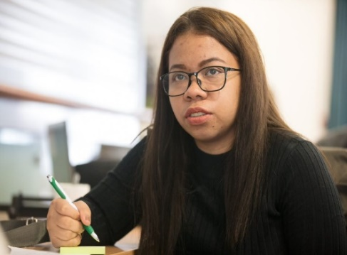
- Motivating and facilitating groups of youth with disabilities
- Ethnics and safeguarding
- the importance of storytelling and social media in advocacy
- the Sustainable Development Goals
- National policy for Youth with disabilities

This training will equip you with the skills necessary to encourage and lead other youth with disabilities to participate in social media advocacy campaign and present their experiences of employment to policy makers.

Youth with disabilities will also be invited to submit innovative digital solutions to the challenges they face in employment.
Those with the most promising solutions will be able to bring their ideas to life, developing prototypes for their products and testing them!

Please be aware, the nature of this advocacy project is to provide youth with disabilities with skills and networks necessary to develop employment skills and share their experiences of employment to help policy makers in their countries understand the challenges they may face. The training provided is not intended to have a political message or nature.

“Leonard Cheshire
sparked a new passion
and my outlook on disability activism has now become much more diverse and powerful.”

About the Role

In order to support the implementation of the Youth Advocacy Project, we are looking to recruit energetic and organised youth with disabilities who are passionate about disability-inclusion.

The lead youth advocate volunteer role will embed a strong peer-led approach and provide a leadership opportunity for four youth with disabilities in each country of operation.

Main responsibilities

- Collaborate with LC’s partners to create campaign action plan

- Mobilise and motivate youth with disabilities to participate in the project

- Facilitate online training to youth with disabilities

- Encourage youth with disabilities to submit qualitative data to the online reporting hub

- Support an online trend analysis process to highlight key advocacy messages

- Lead a social media advocacy campaign on the project findings

- Requires a part-time commitment (meaning you can fit it around work, study or family commitments.)

Eligibility

We are welcoming all young people (aged 18-35) regardless of disability type to apply and we will do our best to make any accommodations necessary to ensure you benefit from the project!
Only Thai and Indonesian nationals living in the respective countries may apply.
All applications must be submitted in English.

For further eligibility criteria please follow the link on LC website.

Applications must be submitted via email to Ella.Hylton@leonardcheshire.org
by midnight on Monday 31st August 2020

“I have formed incredible relationships with organizations both nationally and internationally.”

About Leonard Cheshire

Leonard Cheshire is a charity supporting individuals to live, learn and work as independently as they choose, whatever their ability.

We are a global leading inclusive development agency, with 70 years’ experience in supporting people with disabilities.

Our youth leadership programmes work directly with grassroots partners – including Disabled Person’s Organisations - to ensure the voices of youth with disabilities are being heard in the development process.

Benefits of Volunteering with us:

- Build your advocacy and facilitation skills
- Develop your leadership and organisational skills in new and exciting contexts
- Create stronger links with the disability movement and policy makers in your country
- Expand your professional networks and boost your CV
- Gain greater insight into about the issues affecting a range of youth with disabilities
- Receive regular support from our technical experts in the UK head office and regional office team in Bangkok.
- Receive a small stipend and certification of participation

For further information, please do not hesitate to contact us via email or mobile:
Sawang: +66 96-9288761
Lynn: +66 97-2708842!

Deadline: Monday 31st August 2020
Submit via email to
Ella.Hylton@leonardcheshire.org

