Lead Youth Advocate Volunteer Role
August 2020 - March 2021

Are you a young person passionate about disability-inclusive employment rights?

Leonard Cheshire is leading an exciting Youth Advocacy Project in Thailand and Indonesia.

The project will aim to ensure that policy makers are aware of the challenges Youth with Disabilities face in Employment, highlighting the importance of youth-friendly, disability-inclusive employment policies and practices being enforced in all workplaces.

“Leonard Cheshire
sparked a new passion
and my outlook on disability activism has now become much more diverse and powerful.”
Participating youth with disabilities will receive online advocacy training in order to share their experiences of employment. These will be presented to policy makers through a social media advocacy campaign to raise the voice of youth with disabilities.

Youth with disabilities will also be invited to submit innovative digital solutions to the challenges they face in employment.
Those with the most promising solutions will be able to bring their ideas to life, developing prototypes for their products and testing them!

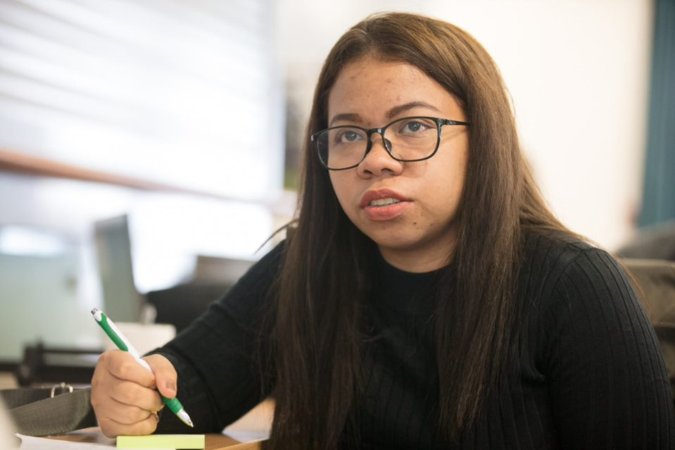

About the Role

In order to support the implementation of the Youth Advocacy Project, we are looking to recruit energetic and organised youth with disabilities who are passionate about disability-inclusion.

The lead youth advocate volunteer role will embed a strong peer-led approach and provide a leadership opportunity for two youth with disabilities in each country of operation.

Main responsibilities

- Collaborate with LC’s partners to create campaign action plan

- Mobilise and motivate youth with disabilities to participate in the project

- Facilitate online training to youth with disabilities

- Encourage youth with disabilities to submit qualitative data to the online reporting hub

- Support an online trend analysis process to highlight key advocacy messages

- Lead a social media advocacy campaign on the project findings

- Requires a part-time commitment (meaning you can fit it around work, study or family commitments.)

Eligibility

Only Thai and Indonesian nationals living in the respective countries may apply.
All applications must be submitted in English.

For further eligibility criteria please follow the link on LC website.

Applications must be submitted via email to Ella.DowdenHylton@leonardcheshire.org
by midnight on Wednesday 12th August 2020

“I have formed incredible relationships with organizations both nationally and internationally.”

About Leonard Cheshire

Leonard Cheshire is a charity supporting individuals to live, learn and work as independently as they choose, whatever their ability.

We are a global leading inclusive development agency, with 70 years’ experience in supporting people with disabilities.

Our youth leadership programmes work directly with grassroots partners – including Disabled Person’s Organisations - to ensure the voices of youth with disabilities are being heard in the development process.

Benefits of Volunteering with us:

- Build your advocacy and facilitation skills
- Develop your leadership and organisational skills in new and exciting contexts
- Create stronger links with the disability movement and policy makers in your country
- Expand your professional networks and boost your CV
- Gain greater insight into about the issues affecting a range of youth with disabilities
- Receive regular support from our technical experts in the UK head office and regional office team in Bangkok.
- Receive a small stipend and certification of participation
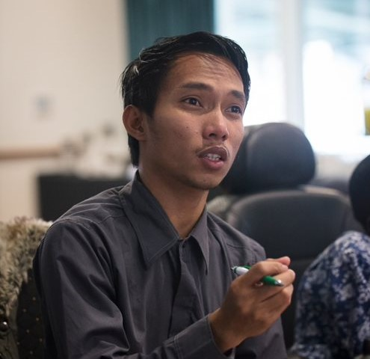

Deadline: Wednesday 12th
August 2020
Submit via email to
Ella.DowdenHylton@leonardcheshire.org

