Accessible Transport

For disabled people good quality, accessible public transport can make the difference between getting out to work and seeing family and friends instead of feeling isolated and excluded from community life.

Leonard Cheshire welcomes the Government’s recently published Inclusive Transport Strategy which includes:
- A requirement for new rail franchise bidders to commit to providing enhanced disability awareness training for staff
- A pause on “Shared-Space” schemes which were of concern to visually impaired people
- £300m of funding for Access for All

Leonard Cheshire’s ‘Lets Get on Board’ campaign recognises that step-free access to rail platforms and step-free access to trains remain significant challenges for many disabled rail travellers.

Our research with over 1,600 disabled adults found that 35 per cent of disabled people say they have experienced problems using trains in the last year.

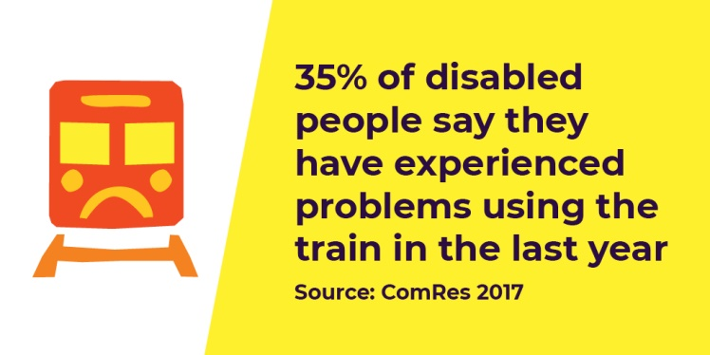

Disabled people experience a range of negative consequences as a result of inaccessible transport including having to miss social engagements or a hospital appointment.

Poor access to transport also has a negative impact on pursuing career and educational opportunities. Disabled people tell us this has resulted in them turning down job offers, missing interviews or not taking up an educational training course.

We want good quality, accessible public transport so that disabled people can live, learn and work as independently as they choose.

Journeys should be accessible from end to end – that means being able to get into the station, onto the train, off the train, and out of the station the other side.

Key issues:

- Access for All

Access for All is a Government programme which funds station infrastructure improvements to provide obstacle free, accessible route to and between platforms.

Although the programme has been running for nearly 20 years progress has been painfully slow with too many stations across the country remaining inaccessible to disabled people.
Mark S: ‘It means you have to consider which jobs to go for, some are just not an option.

If someone offered you a promotion and you think there’s a train station around the corner but scope it out… and there’s steps then it will make the difference between going for the job or not.’

Network Rail are at present inviting nominations for eligible stations following on from the Government’s commitment of up to £300m for Access for All in Control Period 6.

However, this is clearly not sufficient to ensure swift and widespread changes to station infrastructure across the country.

- Step free transfers from train to platform

Even where stations have step free access to platforms, step-free transfers between platform and train is almost a universal challenge for disabled rail users.

Whilst the advance booking system to secure assistance is of value, and the new assistance app is a positive development, Leonard Cheshire too often receives accounts from disabled users across the rail network of the failure of pre-booked support to actually be in in place.

This causes anxiety for disabled passengers, who have told us of feeling stranded and completely helpless, sometimes having to rely on members of the public to enable them to disembark at the correct location.

More needs to be done to develop innovative solutions so disabled people are able to embark and disembark trains independently and confidently at times and locations of their choice.

Chloe T: ‘I have to book a taxi, assistance and a train ticket in advance.

I get really anxious that assistance is not going to be there or that there may not be a member of staff there and I panic. I can often be late for appointments as I have to wait for assistance to get on the train.’

What you can do after the debate?

We want your support to ensure all train operators and everyone responsible for providing train travel are meeting the needs of disabled people so they experience good quality, accessible, end-to-end train travel.
- Write to the train operating companies in charge of stations in your constituency to ask what steps they are taking to improve accessibility. We have written a draft letter to help with this process.

Other issues:

Whilst our ‘Lets Get on Board’ campaign focuses on physical access when travelling by train, there are a number of other issues faced by disabled people when using public transport.

It is therefore pleasing to see the following areas identified as key areas within the Inclusive Transport Strategy, in addition to physical infrastructure:

- Staff Training
- Awareness and enforcement of passenger rights
- Improving information
- The future of inclusive transport

Staff Training:

The Strategy commits the Department for Transport to have developed a disability equality and awareness training package by 2020. It is important that disabled people are involved in the whole process; from development, to design, to delivery of any training.

The proposed Inclusive Transport Accreditation Scheme is welcome, but it is voluntary. It is vital that this training is mandatory and is a key component for anyone working in public transport.

Awareness and enforcement of passenger rights:

We know that a lack of disability awareness from the public is a huge barrier to accessing transport. Disabled people we speak with have told us they face hostility or negative attitudes from other people when using public transport.

Therefore the Public Awareness campaign promised in the strategy for 2019 is much needed. This must be led by disabled people properly resourced and to make passengers more disability aware.

The mandatory annual reports from new rail franchise operators on what activity has been conducted to improve accessibility for rail passengers, to be published by the DfT is a positive step in holding operating companies to account.

Improving information:

Government and the rail operating companies must do more to ensure people are aware of the Passenger Assist Scheme.

When problems arise on the transport network - for example a lift or escalator closure - it is important information is conveyed in a manner that is accessible for disabled passengers.

Want to know more?
Philip Brownlie, Public Affairs Manager Leonard Cheshire
66 South Lambeth Road
London SW8 1RL
T: +44 (0)203 242 0266
philip.brownlie@leonardcheshire.org
www.leonardcheshire.org

ComRes 2017
ComRes 2017
ComRes 2017

