Leonard Cheshire

Gender Pay Gap Report – 2018

As a charity in the UK and internationally, we strive to build a fairer, more inclusive society. One that recognises the positive contributions we all make, and where we are all proud to play our part.
In keeping with this, Leonard Cheshire is committed to building a diverse and inclusive workplace for our employees. Through our initiatives and strategies, we work hard to attract, develop and offer rewarding careers to employees regardless of their race, sexual orientation, religion, age, gender, or disability.
We are actively identifying and removing any barriers and constraints that may impact on
our ability as an organisation to have diversity in our workplace.

Gender pay reporting
The Equality Act 2010 (Gender Pay Gap Information) Regulations 2017 requires us to carry out Gender Pay Reporting. This report is based on a snapshot from Leonard Cheshire on 5 April 2018. We have applied the standard methodologies required by the regulations.

Organisational context
Leonard Cheshire is a charity supporting disabled people in the UK and around the world to fulfil their potential and live the lives they choose. Most of our UK workforce (95%) is employed in our UK care operations. In line with norms in the social care sector, most of our staff are female (80%). A higher proportion of female workers is also common in the charity sector.

Headline gender pay gap
The gender pay gap is defined as the difference between the mean or median hourly rate of pay that male and female employees receive.

The median pay gap is the difference between the midpoints in the ranges of hourly earnings of men and women. The mean pay gap is the difference between average hourly earnings of men and women.

At Leonard Cheshire there is a median gap of 0.2 per cent in favour of women, compared to a UK median of 17.9% in favour of men.

Our mean calculation reflects a larger pay gap, with women earning 7.4% less than male employees on average. The UK mean pay gap is 17.1%, according to the latest figures from the Office of National Statistics.
The following table reflects our median and mean pay gap figures, in the context of the UK, but also different sectors. Our gender pay gap figures are compared against the national mean for fulltime employees and all employees, as per the Office of National Statistics.
Organisation/source | Category | Median | Mean
Leonard Cheshire | All staff | -0.2% | 7.4%
XpertHR survey | Not-for-profit sector | 7.1% | 7.6%
 | All sectors | 11.3% | 13.7%
Office of National Statistics (ONS) | Fulltime staff | 8.6% | 13.7%
 | All staff | 17.9% | 17.1%
Leonard Cheshire does not operate a bonus scheme, so the figures reflected are for ordinary earnings only.

The same data is reflected in the graph below:
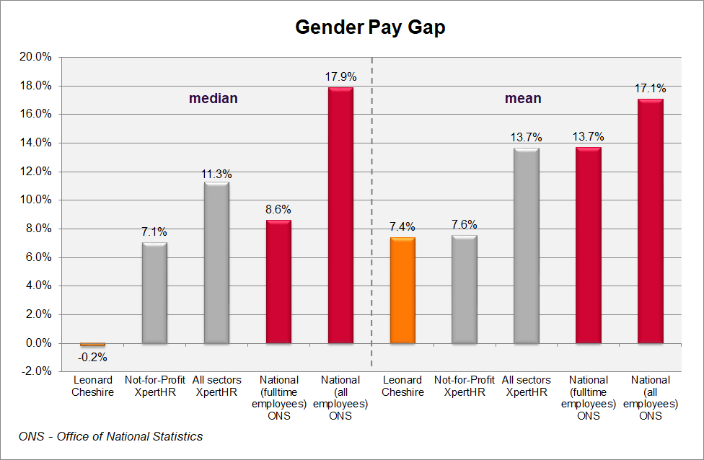

Comparison to previous year
The ratios for April 2018 are broadly in line with those for April 2017, as reflected below:
 | 2017 | 2018 | Diff
Median | -0.7% | -0.2% | 0.4%
Mean | 8.0% | 7.4% | -0.6%

The median ratio remains close to neutral, while the gender pay gap as measured by the mean has reduced since last year.

The following illustrates the same comparison graphically.
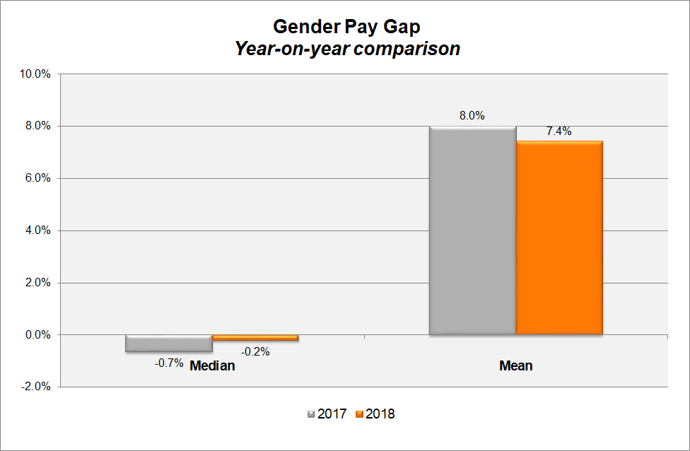

Proportion of male and female employees by quartile group
In line with the social care and charity sectors, Leonard Cheshire employs more women than men, with 80% of our employees being female, and 20% being male.

In the below table, we have divided our workforce into four equal groups ordered from the lowest to highest paid. This shows that our female staff are distributed across these groups in a way that closely reflects the ratio of female and female staff across the whole organisation.

The proportion of male and female employees in Leonard Cheshire in each of the quartiles is as follows:
Quartile groups | Female | Male
Lower | 79% | 21%
Lower middle | 81% | 19%
Upper middle | 81% | 19%
Upper | 79% | 21%
All | 80% | 20%

The chart below shows the same quartile gender splits:
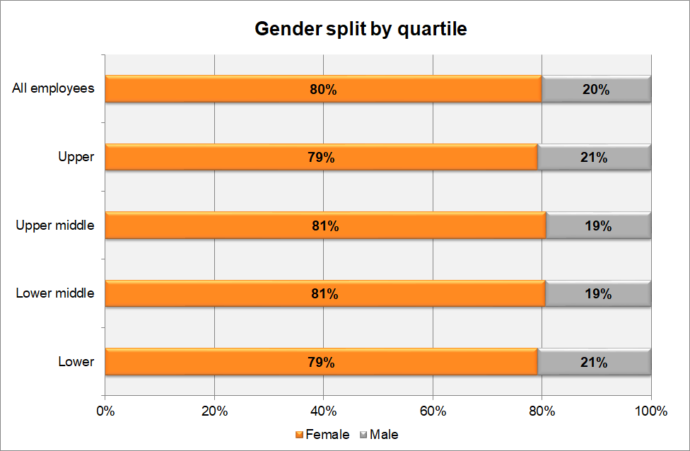

Findings from our gender pay gap analysis
Around 91% of our employees are hourly workers in our UK care operations so the median pay rate is strongly influenced by the size of this group.

The pay framework of hourly paid care operations employees has been reviewed and standardised by role, taking account of small regional variations for market factors. This has resulted in very consistent pay levels between male and female staff for this group, contributing to the almost neutral median gender pay gap for the organisation.

An integrated pay framework covers all salaried staff, based on the scale and level of complexity of the respective roles, so on an equivalent (“like for like”) basis, there is pay equity across these roles too.

Women are relatively more strongly represented in lower level roles, which include both hourly paid social care roles, and more junior salaried roles. This brings down the average earnings for female employees relative to their male colleagues. While women are equally represented at the senior levels of the organisation, this does not offset the impact
of significantly higher proportions of women in relatively smaller roles.

Overall this contributes to the negative mean pay gap of 7.4% in favour of male employees.

Responses to the gender pay gap analysis
Leonard Cheshire is working to address our gender pay gap by:
- Working to continue to enhance the culture of flexible working practices, to minimise career obstacles for working parents, typically biased towards women.
- Building awareness of the structural gender bias in the social care and the charity sector, working consciously to counteract this.
- Introducing training modules around unconscious bias, to increase awareness, and further build our organisation as an inclusive workplace.
- Implementation of revised reward frameworks, enhancing cross-organisational consistency and internal equity of pay, enabling more integrated analysis.
- Ongoing review of our recruitment process to ensure fairness in our process and parity in the offers being made to new starters.
- Examining our recruitment practices to seek to attract more women into typically male-dominated roles.
- Review of the existing performance management process, in support of unbiased performance assessments which contribute to employee development and growth.
- Investing in technical and leadership development, to assist in career progression.
- Review of our talent management and career development processes, with due consideration of career progression of women in the organisation.

While the structural aspects of the gendered nature of the social care and charity sector will continue to challenge us in narrowing our gender pay gap, we are committed to working towards this goal, while we continue to build our organisation as an inclusive, fair and empowering workplace.

Lynn Barbour
Head of Reward
Leonard Cheshire

25 February 2019

